Data Model

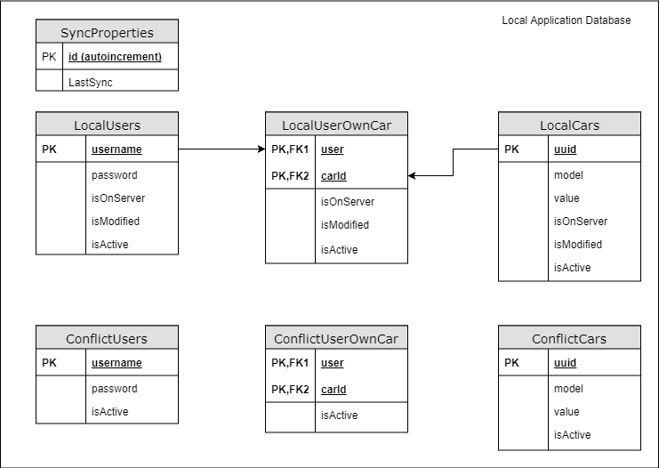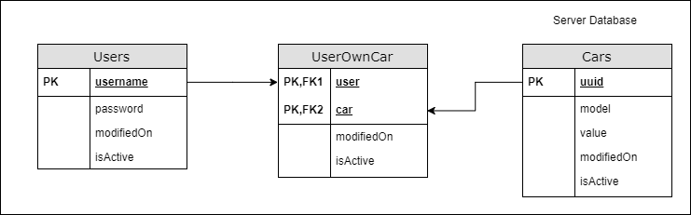

Notes:

* The timestamps of modifications always have to be the time of the server to avoid problems on synchronizations.
* The conflicts, for now, it will handle by the user. We will show the conflict to the user and they have to choose what to do.

Links:

* <https://xamarinhelp.com/mobile-database-bi-directional-synchronization-rest-api/>
* <https://success.outsystems.com/Documentation/10/Developing_an_Application/Use_Data/Offline/Offline_Data_Sync_Patterns/Read%2F%2FWrite_Data_with_Conflict_Detection>